***Name:*** Moataz Mohamed Ebrahim Tag ***B. N:*** 946 ***Email:*** [moataz196058@feng.bu.edu.eg](mailto:moataz196058@feng.bu.edu.eg)  
  
***Topic:*** Artificial intelligence  
  
***Examiners committee:***  
 Dr.Ahmed Bayoumi

Dr. Shady Elmashad

Dr. Abdelhamid Attaby

Application brief:  
**Artificial Intelligence** or **AI** is a branch of computer science which displays or simulates Human **intelligence** by machines or a process to make machines think intelligently. **AI** is achieved by examining how human brain thinks, and how humans learn, decide, and work while trying to solve a problem. That means, AI is not specifically related to computer science. This is a field of study that encompasses human behavior, biology, psychology, and even language and linguistics. There’s still not a common consensus among academicians about its definition. The main thing in AI is machine learning.  
 First thing to understand about machine learning is that it is an application of AI. It is the process by which we create systems that have ability to learn with experience. For instance, the systems which automatically identify spam emails are trained to do so by exposing them to millions of e-mails which are spammy and non-spammy in nature. With more data, the program is able to understand and learn what makes an email.

Machine learning is different from a fully-AI system in the way that it does not know what it was trained to do. For instance, the above-mentioned AI system can identify spams, but it will never be able to tell why it is doing that. Or if a new type of email comes in, it will fail to understand it.  
  
**Why** I chose this application? because AI is the new buzzword of the 21st century. Artificial intelligence is coming into our lives faster than we had anticipated. It is helping us in shopping. It is at the other end when you’re talking to customer service center. It is driving our cars and even recommending you videos on YouTube. It is making sure that it knows about you more than you do.  
 **Applications** of AI: I will give 4 applications  
 **first,** Artificial Intelligence in Healthcare: Companies are applying machine learning to make better and faster diagnoses than humans. One of the best-known technologies is IBM’s Watson. It understands natural language and can respond to questions asked of it. The system mines patient data and other available data sources to form a hypothesis, which it then presents with a confidence scoring schema. AI is a study realized to emulate human intelligence into computer technology that could assist both, the doctor and the patients in the following ways:  
By providing a laboratory for the examination, representation and cataloguing medical information, By devising novel tool to support decision making and research and By integrating activities in medical, software and cognitive sciences  
**second,** Artificial Intelligence in business: Robotic process automation is being applied to highly repetitive tasks normally performed by humans. Machine learning algorithms are being integrated into analytics and CRM (Customer relationship management) platforms to uncover information on how to better serve customers. Chatbots have already been incorporated into websites and e companies to provide immediate service to customers. Automation of job positions has also become a talking point among academics and IT consultancies.  
**third**, AI in Autonomous vehicles: Just like humans, self-driving cars need to have sensors to understand the world around them and a brain to collect, processes and choose specific actions based on information gathered. Autonomous vehicles are with advanced tool to gather information, including long range radar, cameras, and LIDAR. Each of the technologies are used in different capacities and each collect different information. This information is useless, unless it is processed, and some form of information is taken based on the gathered information. This is where artificial intelligence comes into play and can be compared to human brain. AI has several applications for these vehicles and among them the more immediate ones are as follows: Directing the car to gas station or recharge station when it is running low on fuel. Adjust the trips directions based on known traffic conditions to find the quickest route. Incorporate speech recognition for advanced communication with passengers.  
**fourth**, in education: It automates grading, giving educators more time. It can also assess students and adapt to their needs, helping them work at their own pace.

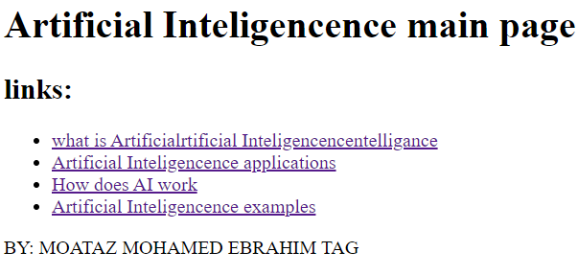***Screen Shots: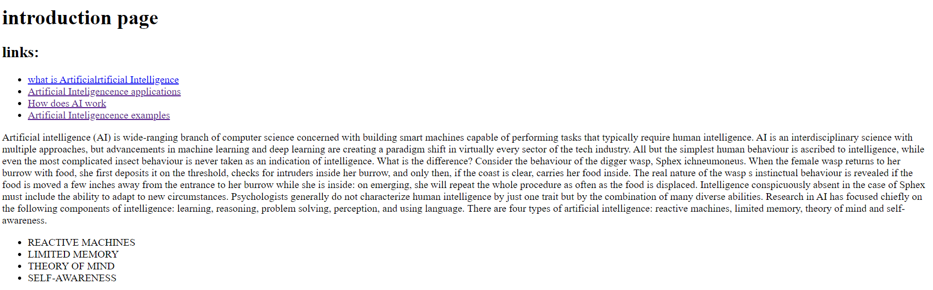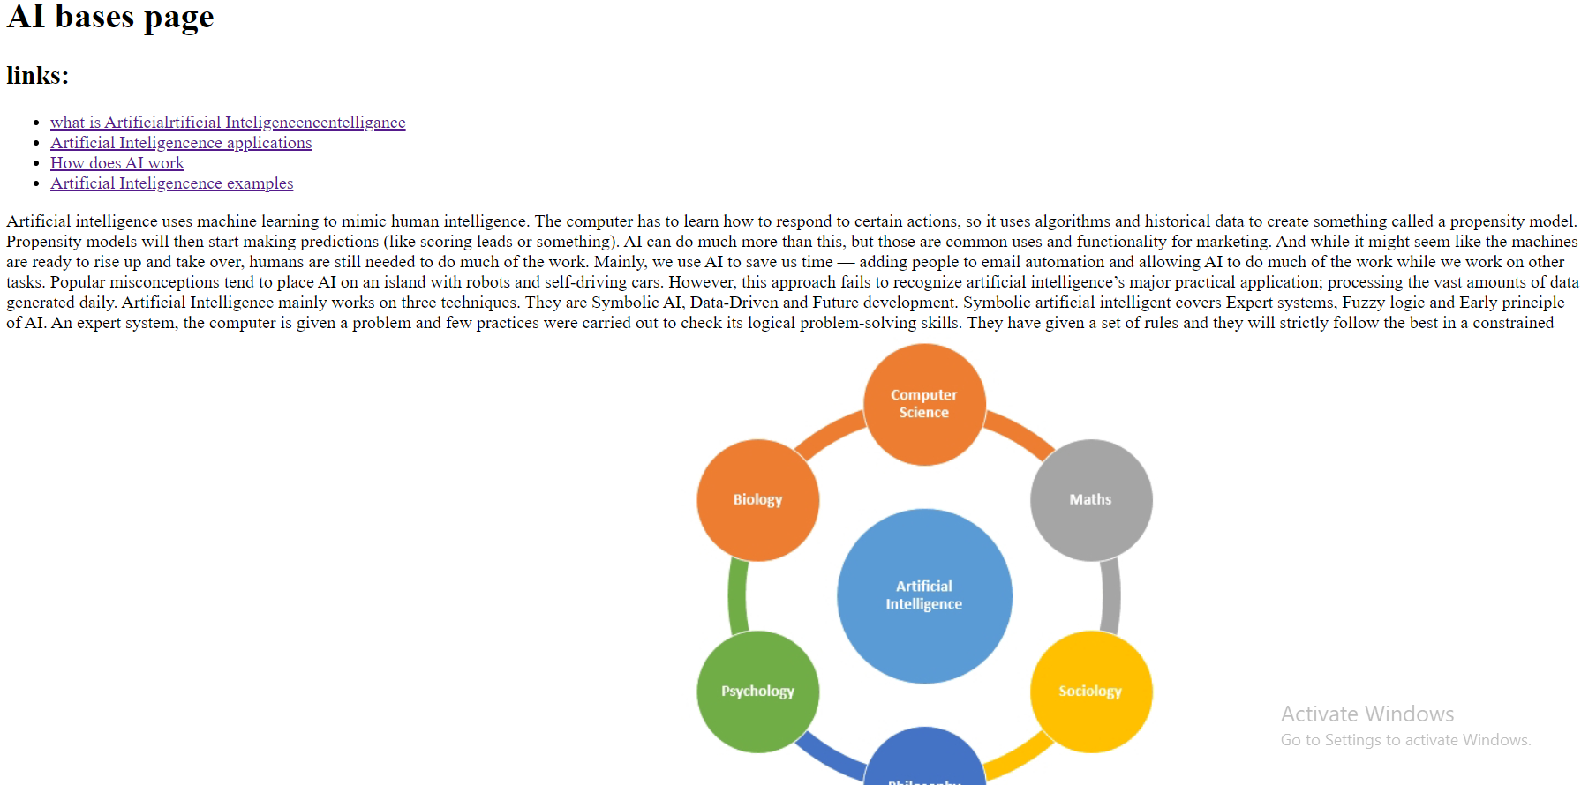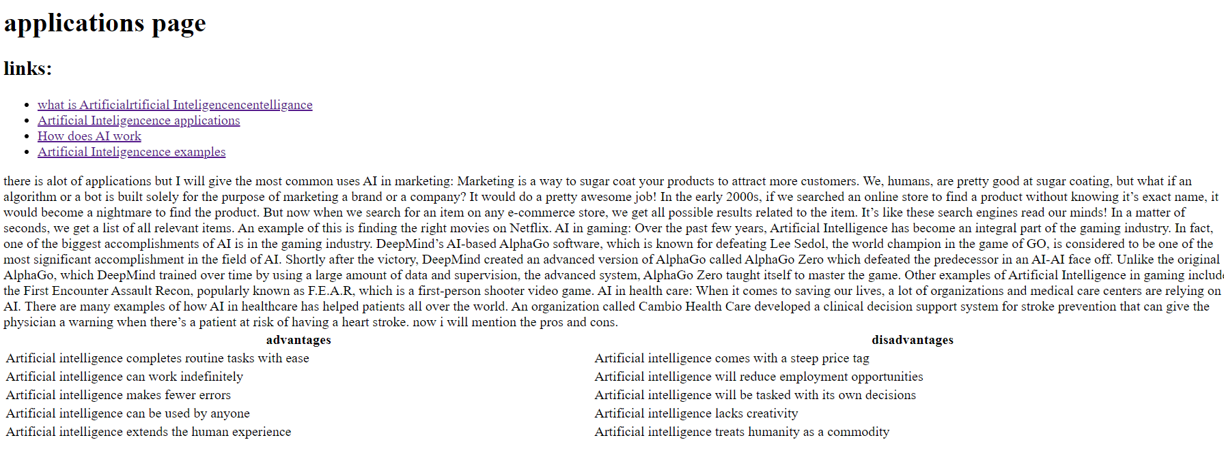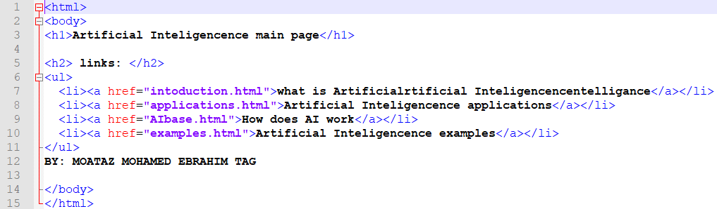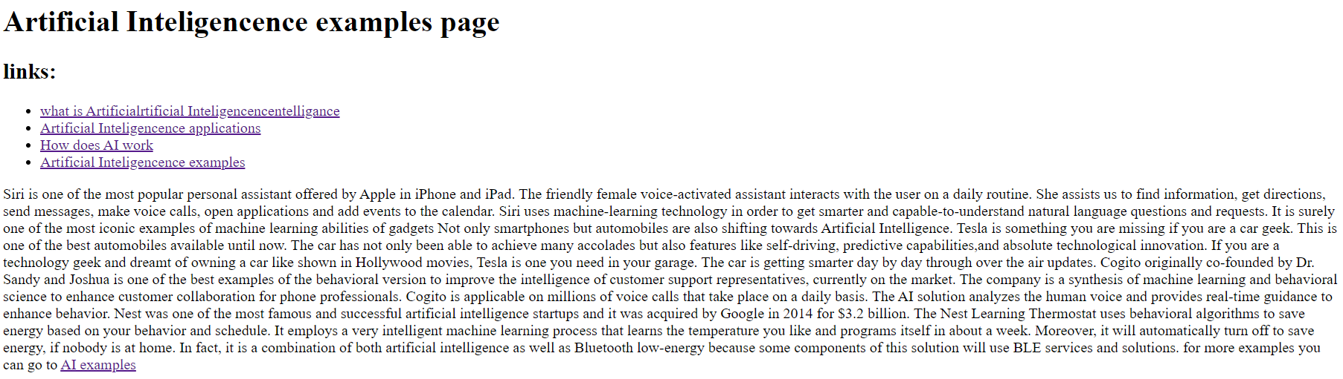source code:***

